Gym Management System

Submitted to:

د / عمرو ناجى

م . م / ابراهيم رياض

م / تقى احمد

Submitted by:

رنا السيد الضعيف

روان محمد السيد

روان محمد غنيم

هشام مصطفى احمد

مريم السباعى صلاح عبد الظاهر

ياسمين محمد عبد الحميد حسن

مريم سامى سيد سلامة

يارا ياسر ابو سريع محمود

هند عبد الناصر محمد

هنا محمد السيد حجاب

**Table of Contents**

1. **Introduction**
2. **Project Overview**
3. **System Architecture**
4. **Features**
5. **GUI (Graphic User Interface)**
6. **Database**
7. **Conclusion**

**1. Introduction**

Welcome to the project documentation for the Gym Management System. This document aims to provide a comprehensive overview of the system architecture, functionalities, installation instructions, and usage guidelines. The Gym Management System is developed using Python programming language and SQLite and is designed to streamline the operations of a gym facility, including employee and member management, trainer scheduling, and payment processing.

**2. Project Overview**

The Gym Management System is developed to automate and simplify various tasks performed in a gym environment. It allows administrators, trainers, and members to efficiently manage their respective roles within the system. Key features include member registration and data, employee registration and data, payment management, and comprehensive reporting capabilities.

**3. System Architecture**

The Gym Management System is structured using a three-tier architecture:

* **Presentation Layer:**
  + Graphic User Interface (GUI) developed using Tkinter library for Python.
  + Provides interactive screens for employees.
* **Application Layer:**
  + Python scripts that implement business logic and interact with the database.
  + Handles user requests, processes data, and updates the database.
* **Data Layer:**
  + SQLite database used to store information such as member details, trainer details and payment histories.
  + Ensures data persistence and facilitates efficient data retrieval.

**4. Features**

### Key features of the Gym Management System include:

* **Member Management:**
  + Add, edit, and delete member profiles.
  + Track member details, health state and membership status.
  + Manage subscriptions and payments.
* **Employee Management:**
  + Maintain employee profiles with specialties and availability.
  + Track employee details and payroll information.
* **Payment Processing:**
  + Manage membership fees, subscriptions, and payments.
* **Reporting and Analytics:**
  + Generate reports on member statistics, health state, and financial summaries.
  + Generate reports on employee statistics, details and payroll information.

**5. GUI (Graphic User Interface)**

**1. LOG IN**

In this part, administrators and receptionist can enter their e-mail and password to login the system and go to welcome page.

**2. Welcome**

Welcome page has eight buttons each button has special icon and go to different frames. We will get to know these frames.

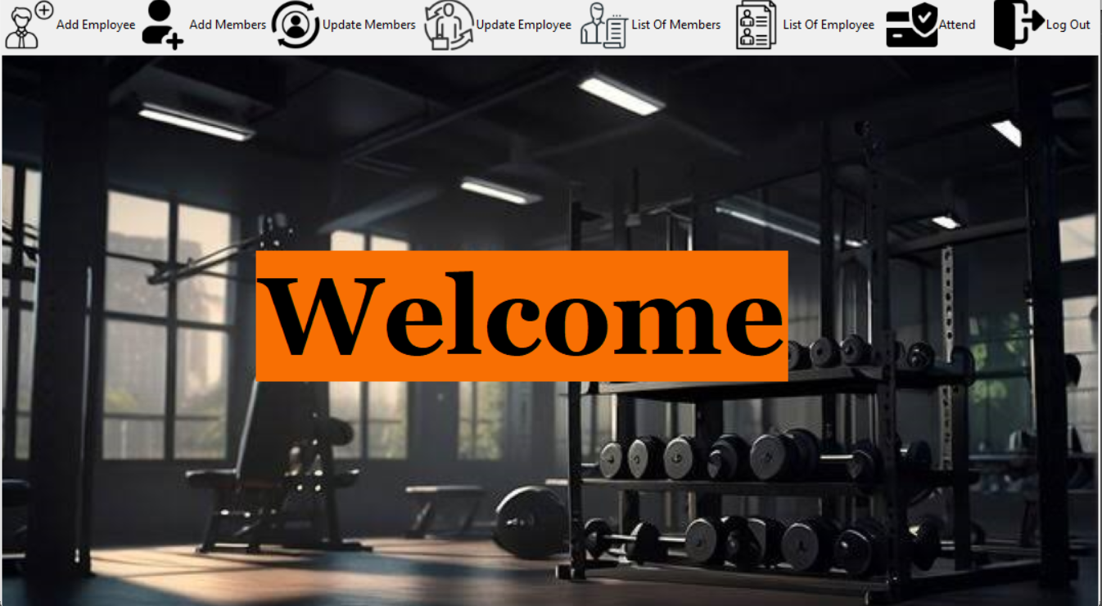

**3. Add New Employee**

administrator use this frame when he needs to add a new employee through his unique ID, Name, Mobile Number, E-mail, Password, Gender, Salary, Position and Age. All data must be filled in and click on save. Back button takes you back to the welcome page.

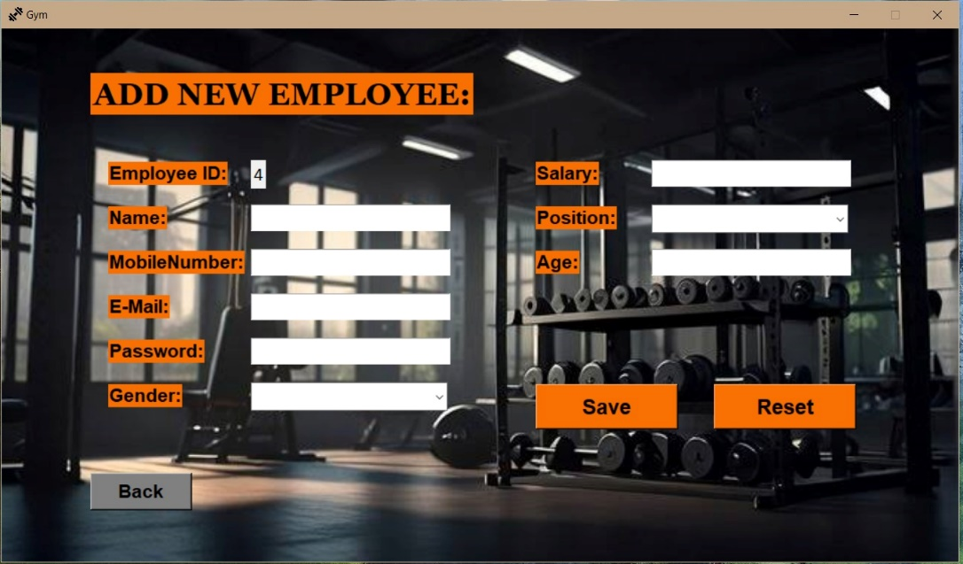

**4. Add New Member**

administrator use this frame when he needs to add a new member in gym through his unique ID, Name, Mobile Number, E-mail, Gender, Weight, Hight, Program, Age, Coins and Coach Name. All data must be filled in and click on save. Back button takes you back to the welcome page.

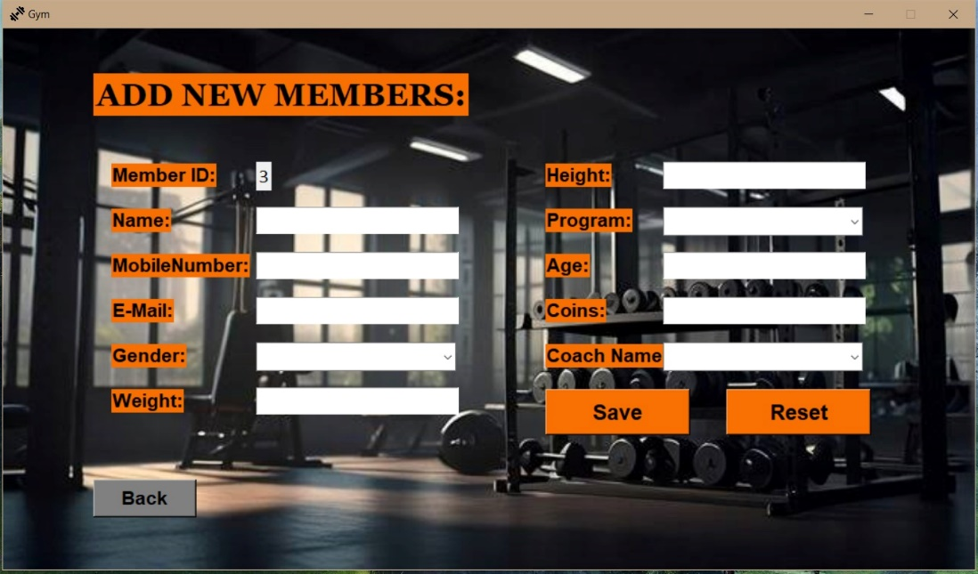

**5. Update And Delete Members**

administrator use this frame when he needs to update or delete a member in gym through his unique ID we can search for the member if it exists, Name, Mobile Number, E-mail, Gender, Weight, Hight, Program, Age, Coins and Coach Name. All data must be filled in and click on update or delete when change data or delete when he need to delete the member. Back button takes you back to the welcome page.

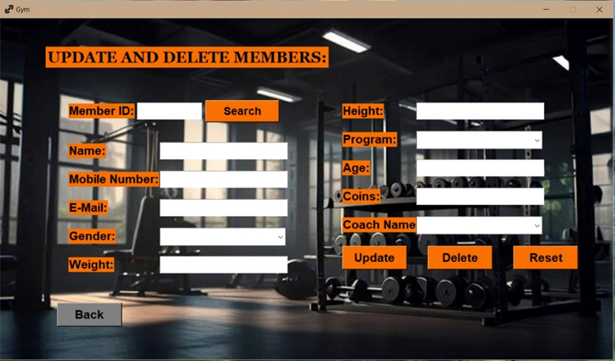

**6. Update And Delete Employees**

The update and delete employees frame contains: Employee ID as a text field for entering the Employee ID to search for an existing employee's details. Employee Information Fields like name, mobile number, e-mail, gender, password, age, salary, and position. Action Buttons: update, delete, reset. A Back button is provided, to return to the previous page.

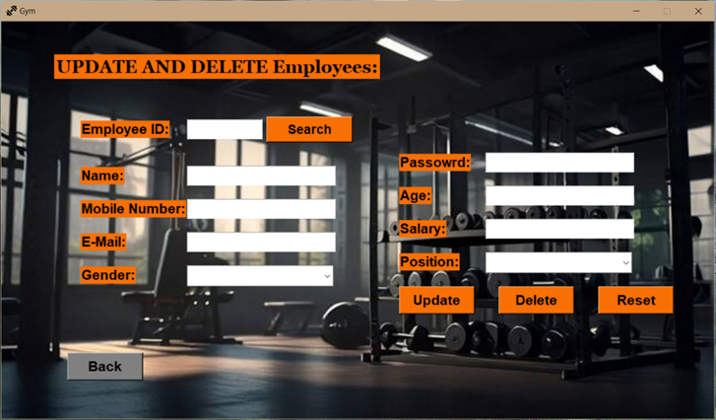

**7.**  **List OF Members**

The frame contains A Table that shows the Name, ID, age, mobile number, e-mail, gender, coins, weight, height and program of members. A Back button is provided, to return to the previous page.

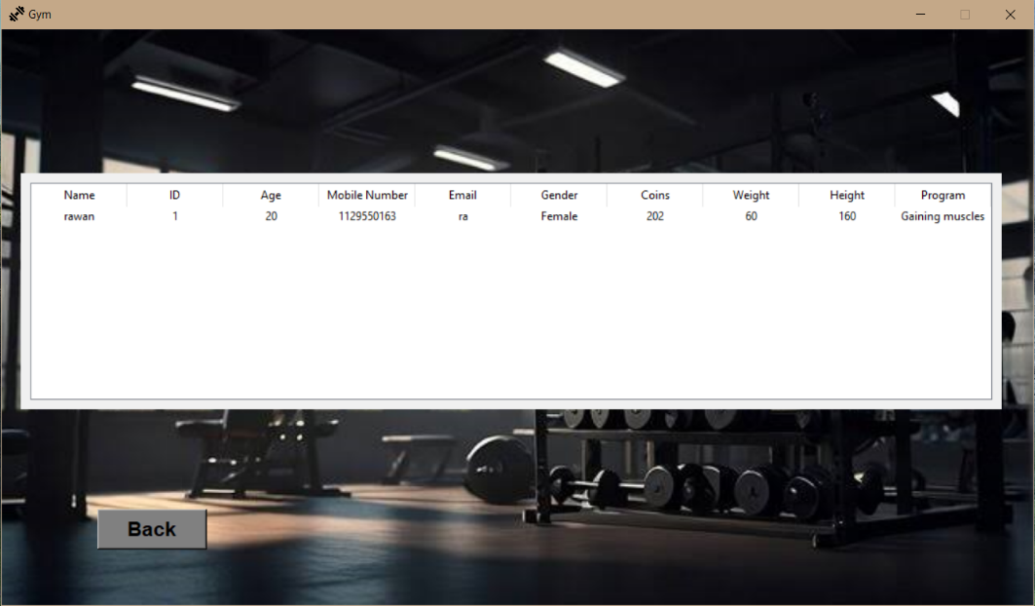

1. **List OF Employee**

The frame contains a table that shows Employee Details such as the Name, ID, age, mobile number, e-mail, gender, password, position and salary. A Back button is provided, to return to the previous page.

1. **Checking attendance**

The checking attendance frame contains All the essential info to handle attendance-related information such as member ID, name. It’s responsible for checking member’s attendance by decreasing its coins by one each time he attends. Once he is out of coins, it displays a message requests him to recharge.

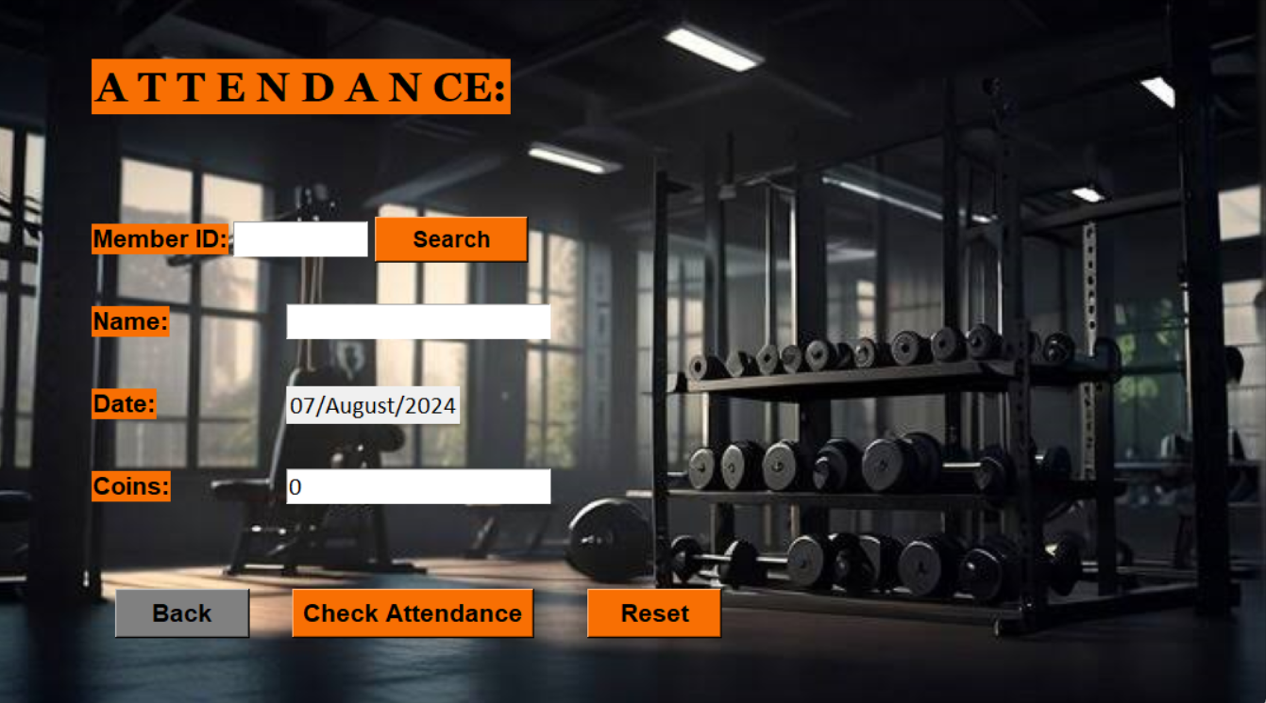

**10. Log Out**

Logout button to return to the login page.



**6. Database**

* **ERD (Entity–Relationship Diagram)**

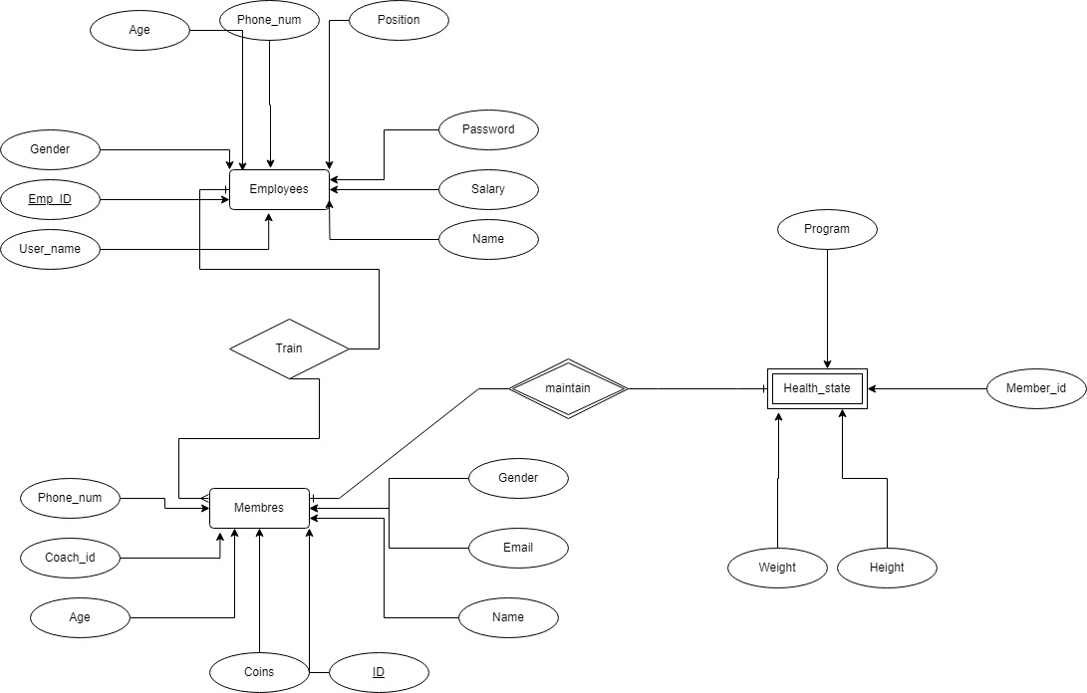

* **Mapping**

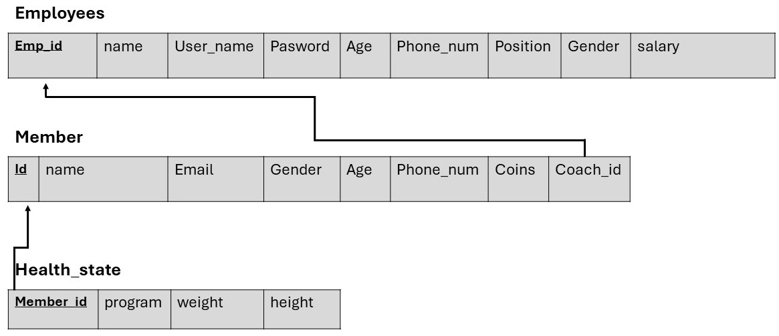

**7. Conclusion**

The Gym Management System is designed to enhance operational efficiency, improve member satisfaction, and optimize administrative tasks in a gym setting. With its modular architecture, user-friendly interface, and robust features, it provides a scalable solution for managing gym operations effectively.

THANK YOU